Jira Software

|  |  |
| --- | --- |
| Date | 19 September 2022 |
| Team ID | PNT2022TMID49243 |
| Project Name | Project - Traffic and Capacity Analytics in Major ports |

**RoadMap**

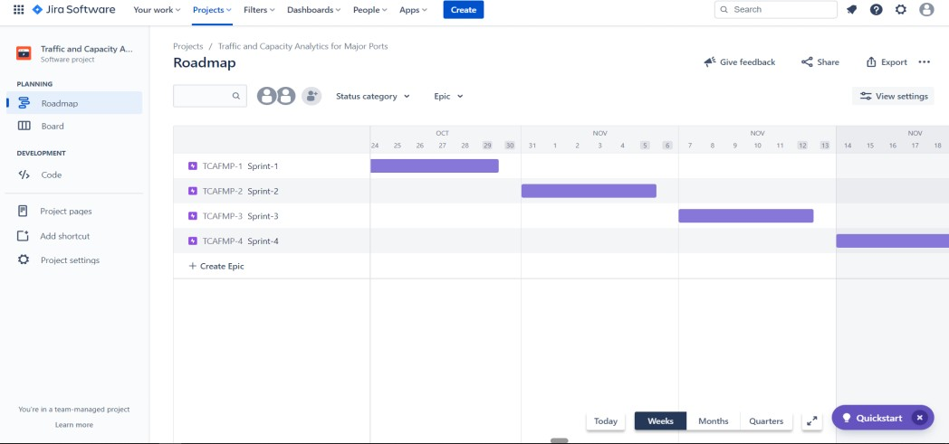

BackLog

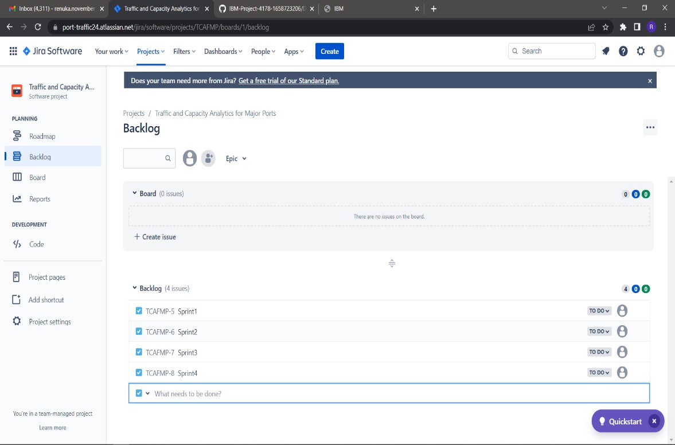

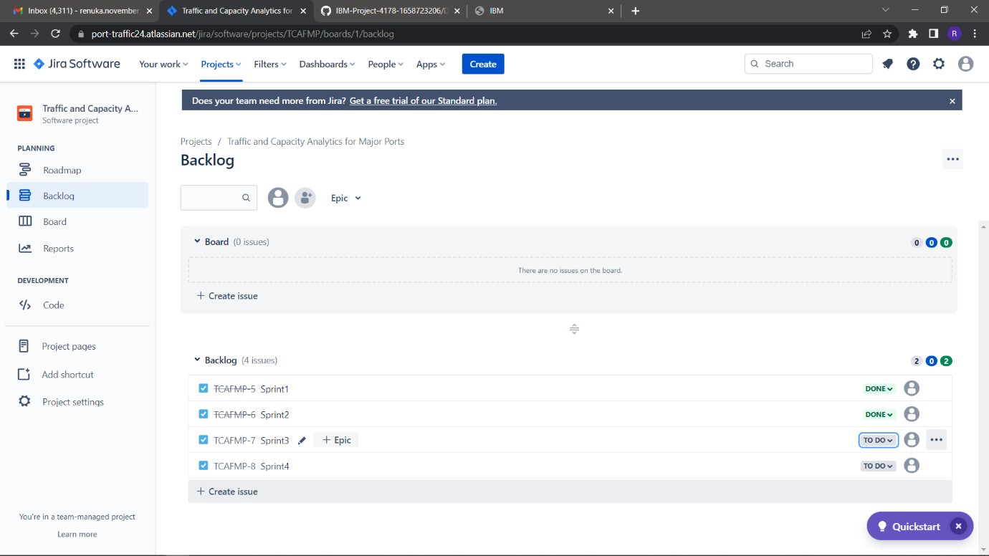

Board

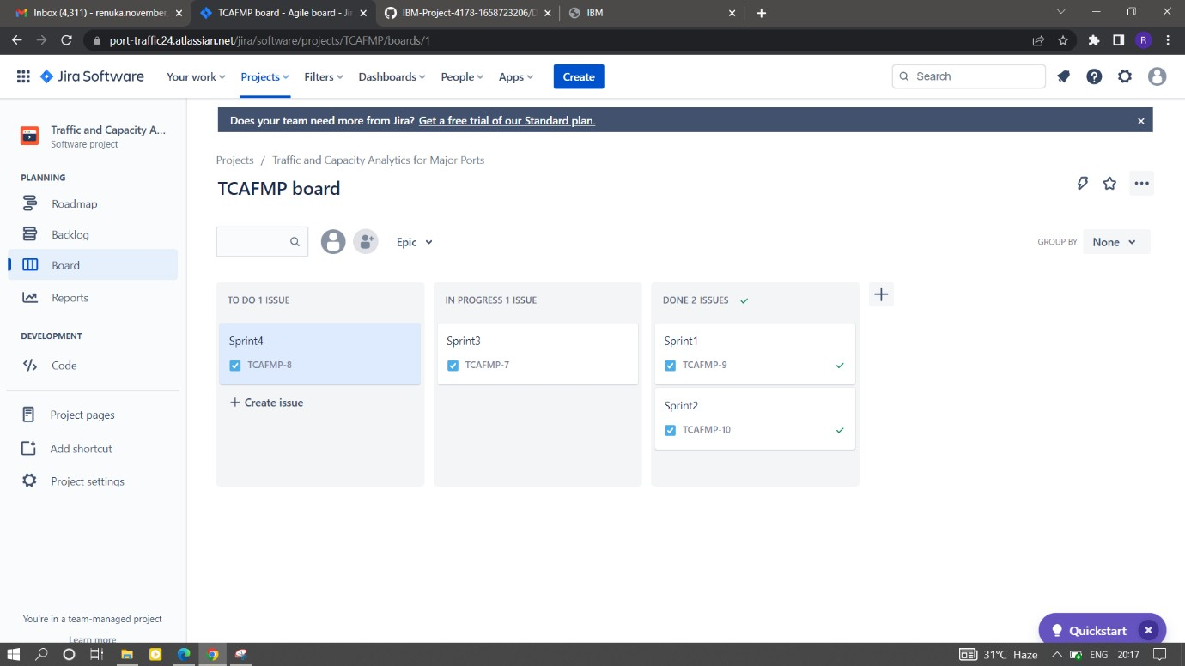

BurnUpChart

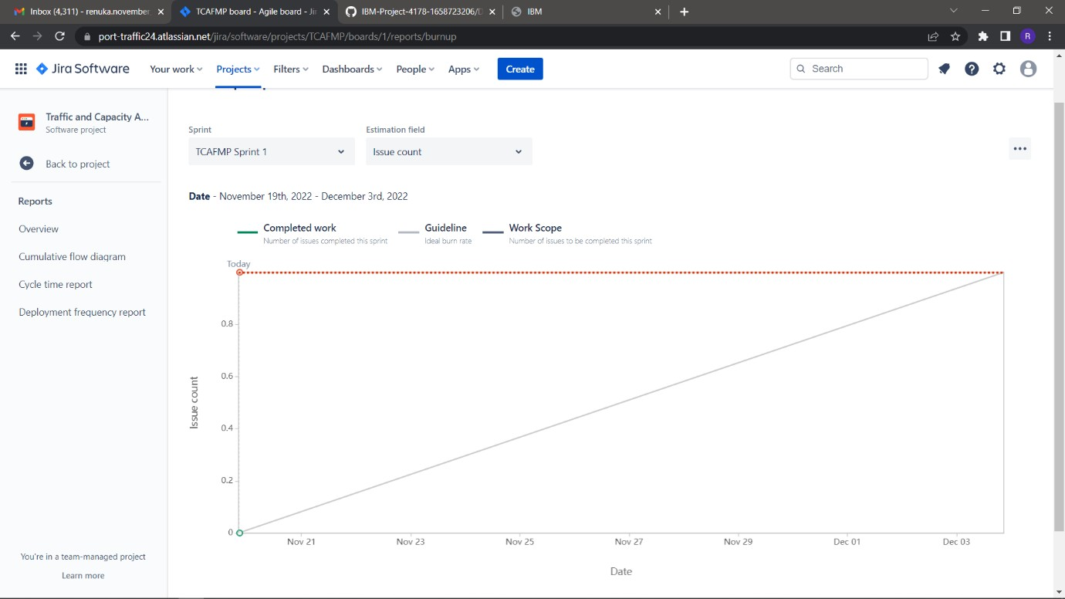

Sprint Burndown Chart

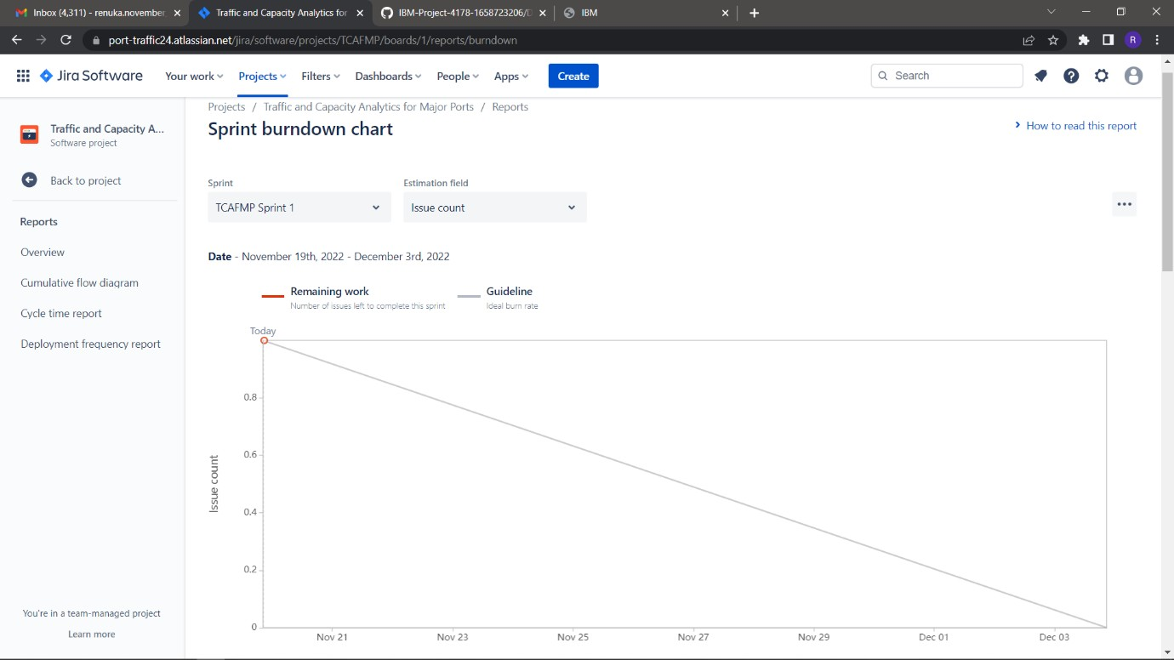

**Link:** [**https://port-traffic24.atlassian.net/jira/software/projects/TCAFMP/boards/1/reports**](https://port-traffic24.atlassian.net/jira/software/projects/TCAFMP/boards/1/reports)